PRT563 Advanced Data Management
Assessment 4: Group Project Report
Migrating a Perishable Supply Chain Database to Neo4j
Graph modelling, Cypher use cases and Graph Data Science evaluation
Group 12
Student name | Student ID
Uttam Shrestha | S396560
Sarin Uprety | S394012
Yogesh Basnet | S394043
Abhisek Tamang | S396739

Charles Darwin University
Submitted: 16 October 2026
Word count: 5,098 (excluding title page, contents, lists of figures and tables, and references)
Repository: [GitHub Link]
URL: https://github.com/Uttam1618/PRT563_A4_Group12_Neo4j_Supply_Chain

Table of Contents
Executive summary 1
1 Introduction 1
2 Methodology and data preparation 1
2.1 Working principles 1
2.2 Data audit and regeneration 1
3 Task 1: Graph data model 2
3.1 Translation strategy 2
3.2 The resulting model 2
3.3 Alternatives considered 3
4 Task 2: Import and indexes 3
5 Alternative strategy experiment: Model A versus Model B 5
6 Task 3: Query use cases 6
6.1 Q1 Cold chain breach at receiving (simple) 6
6.2 Q2 Supplier and DC scorecard (moderate) 7
6.3 Q3 Product recall trace (complex) 8
6.4 Q4 Stock loss ledger by supplier (most complex) 9
7 Task 4: Centrality 11
7.1 Use case and projection 11
7.2 Algorithms 11
7.3 Evaluation against ground truth 11
8 Task 5: Similarity 12
8.1 Use case and projection 12
8.2 Methods 12
8.3 Hold out evaluation 12
9 Discussions and limitations 13
10 Conclusion 14
References 15
Individual contributions 16

List of figures
Figure 1. Model B graph data model with node counts, keys and relationship properties 3
Figure 2. Import verification: totals (Check 3), relational integrity (Check 4) and stock and sales rules (Check 4b) 4
Figure 3. Schema of the imported graph from db.schema.visualization() 5
Figure 4. Database hits for seven benchmark questions on Model A and Model B 6
Figure 5. Q1 result: ten worst cold chain breaches 7
Figure 6. Q2 result: delivery scorecard for all seven consignors 8
Figure 7. Q3 result: Baby Spinach recall trace 9
Figure 8. Q4 result: stock loss by supplier (AUD at cost; markdown at revenue forgone) 10
Figure 9. Spearman correlation of each centrality configuration with supply risk 11
Figure 10. Hold out evaluation of four similarity methods against a best seller baseline 13

List of tables
Table 1. Optimisations that turn Model A into Model B 2
Table 2. Indexes created by import.txt and the queries they support 4
Table 3. Top three Jaccard partners of the high loss products (training period) 13

Executive summary
This report migrates Group 12's Assessment 2 database, which handles the perishable stock supply chain of a four-store supermarket chain in the Northern Territory, to Neo4j. In the sample data 150 violations of 24 business rules were initially identified in an audit, and the transaction tables were then rebuilt using a reproducible simulation that meets all the rules.
The schema was translated twice: a naive version with one node per table (Model A) and an optimised version (Model B) constructed using 7 documented transformations. Model B contains the same information in 24% fewer nodes and 13% fewer relationships, and a controlled benchmark reveals that it requires half the number of hops and 33.1% fewer database hits. Four Cypher use cases include cold chain breaches, supplier performance, a product recall and a stock loss ledger. The centrality and similarity algorithms have been tested against independent evidence, showing a Spearman correlation of 0.936 with weighted centrality, and Berrimah Regional DC as the most central node, and Jaccard similarity predicting future joint purchase three times more than chance, with bundles targeting the biggest sources of stock loss.

1 Introduction
Group 12’s Assessment 2 database models the supply chain of a supermarket with four Northern Territory stores: Darwin City, Casuarina, Palmerston and Alice Springs. 8 suppliers make deliveries against purchase orders either directly or via two distribution centres (DCs); each delivery is a batch of stock with a use by date, batches are sold or marked down or written off, and there are other disruptions like cyclones that cause delivery delays. Many of the key questions in this area are path related: What customers purchased from a recalled batch, what supplier would be responsible for a loss, which node would be impacted most if it were to fail. In SQL, every such step is a join; while in a graph database, relationships are stored directly and traversed by pointer: this is called index free adjacency (Angles & Gutierrez, 2008; Robinson et al., 2015).
The method and data preparation are explained in Section 2. Sections 3-5 describe the graph model (Task 1), the import (Task 2), and an experiment making comparisons between the optimised model and a naive translation. Section 6 shows four examples of using Cypher (Task 3), Section 7 and 8 give an evaluation of centrality algorithms (Task 4) and similarity algorithms (Task 5) from the Graph Data Science (GDS) library, and Section 9 provides limitations. All work used Neo4j Desktop 2026.09 with Cypher 25 and GDS 2026.09. The submitted repository contains import.txt, queries.txt and the 29 CSV files, as well as algorithms.txt, the Model A experiment, the data preparation scripts and result screenshots.

2 Methodology and data preparation

2.1 Working principles
The project was guided by four principles. First, each number in this report was generated twice: once by an independent Python computation from the CSV files and once by Neo4j, and only when the two matched was the number accepted. Second, all changes to the relational design are backed up by a precondition that is examined against the data. Third, when a selection might be debated both sides, the options were measured and not asserted. Fourth, everything is reproducible: The generator and stochastic algorithms use fixed seeds, and all import statements use MERGE with a constrained key, allowing the script to be run again safely.

2.2 Data audit and regeneration
The Assessment 2 export had 29 tables and 331 rows, which is an insufficient number of rows for graph algorithms to discover a meaningful structure. More seriously, an audit script (audit.py) was created to encode 24 business rules, with 150 violations identified. Stock was sold before its use by date, or before it was received, products were delivered against purchase orders that didn't order them, and deliveries were made that occurred prior to the disruption. These errors would have been propagated into all the results in such a migration.
The master data (stores, shelf bays, products, suppliers, DCs, employees and the three supply disruptions) was kept byte for byte because the assessment allows for justified changes to the relational design; the transaction tables were re-created by a day-by-day simulation of the four stores, from 5 January till 30 August 2026 (generate.py, seed 563). The simulation adheres to all 24 rules and manages to simulate realistic events: the Cyclone Ilsa highway closure in February, the Berrimah DC refrigeration failure of 18–21 April, national carrier industrial action in June and a supplier recall of Baby Spinach on 20 July. The outcome: 16,786 rows in the same 29 csv files, the same columns, and the audit reports 0 violations.

3 Task 1: Graph data model

3.1 Translation strategy
The translation was done in two phases. The general conversion rules give a baseline, Model A: each table becomes a label, each row a node, each column a property and each foreign key a relationship. Model A is complete, with 29 labels, 38 relationship types, 16,786 nodes and 31,740 relationships, but copies the relational structure: there are tables just because a relational schema cannot give a relationship its own attributes or represent a subclass without a separate table. The submitted model (Model B) eliminates that overhead, with seven optimisations (Table 1), each of which is performed only if a precondition check verifies that it is safe for this data..
Table 1. Optimisations that turn Model A into Model B
# | Relational structure | Model B | Precondition checked | Nodes saved
O1 | Subclass tables (perishable, ambient, three employee roles) | Extra labels on one node, e.g. :Product:Perishable | Each product in exactly one subclass; one employee holding two roles is represented exactly | 30
O2 | CONSIGNOR categorisation table | CONSIGNED_BY directly targets the Supplier or DistributionCentre | Any consignor can only be resolved to a single supplier or DC | 7
O3 | Multivalued EMPLOYEE_PHONE | phones list property | At most two phones per employee | 16
O4 | Associative BATCH_COUNT and DISRUPTION_IMPACT | COUNTED {countedQty, systemQty}, AFFECTS {delayDays} | No other table references them | 343
O5 | Weak entity PO_LINE | ORDERS (lineNo, orderedQty, agreedUnitCost) | No foreign key is pointing to PO_LINE | 1,858
O6 | DELIVERY_LINE, 1:1 with STOCK_BATCH | DELIVERED {lineNo, deliveredQty, rejectedQty} | 1,805 lines, 1,805 batches, no orphans | 1,805
O7 | Foreign key columns | Dropped; the relationship carries the link | None needed | 0
 | Total |  |  | 4,059

3.2 The resulting model
Model B (Figure 1) contains 18 node types with 23 labels, and 26 relationship types, and 12727 nodes and 27681 relationships, which is 24% less nodes and 13% less relationships than Model A. No data is lost as each removed row becomes a relationship, a relationship property, a label or a list. The verbs from the Assessment 2 EER diagram (PLACED_WITH, FULFILS, DRAWS_FROM, AUTHORISED_BY) have been reused for the relationship names, thus allowing the model to be traced back to the conceptual design. The composite keys of weak entities (e.g. ShelfBay, SaleLine, SupplyAgreement) have been converted to single surrogate keys (e.g. bay “1:A12”). This means that each node type has just one property uniqueness constraint.
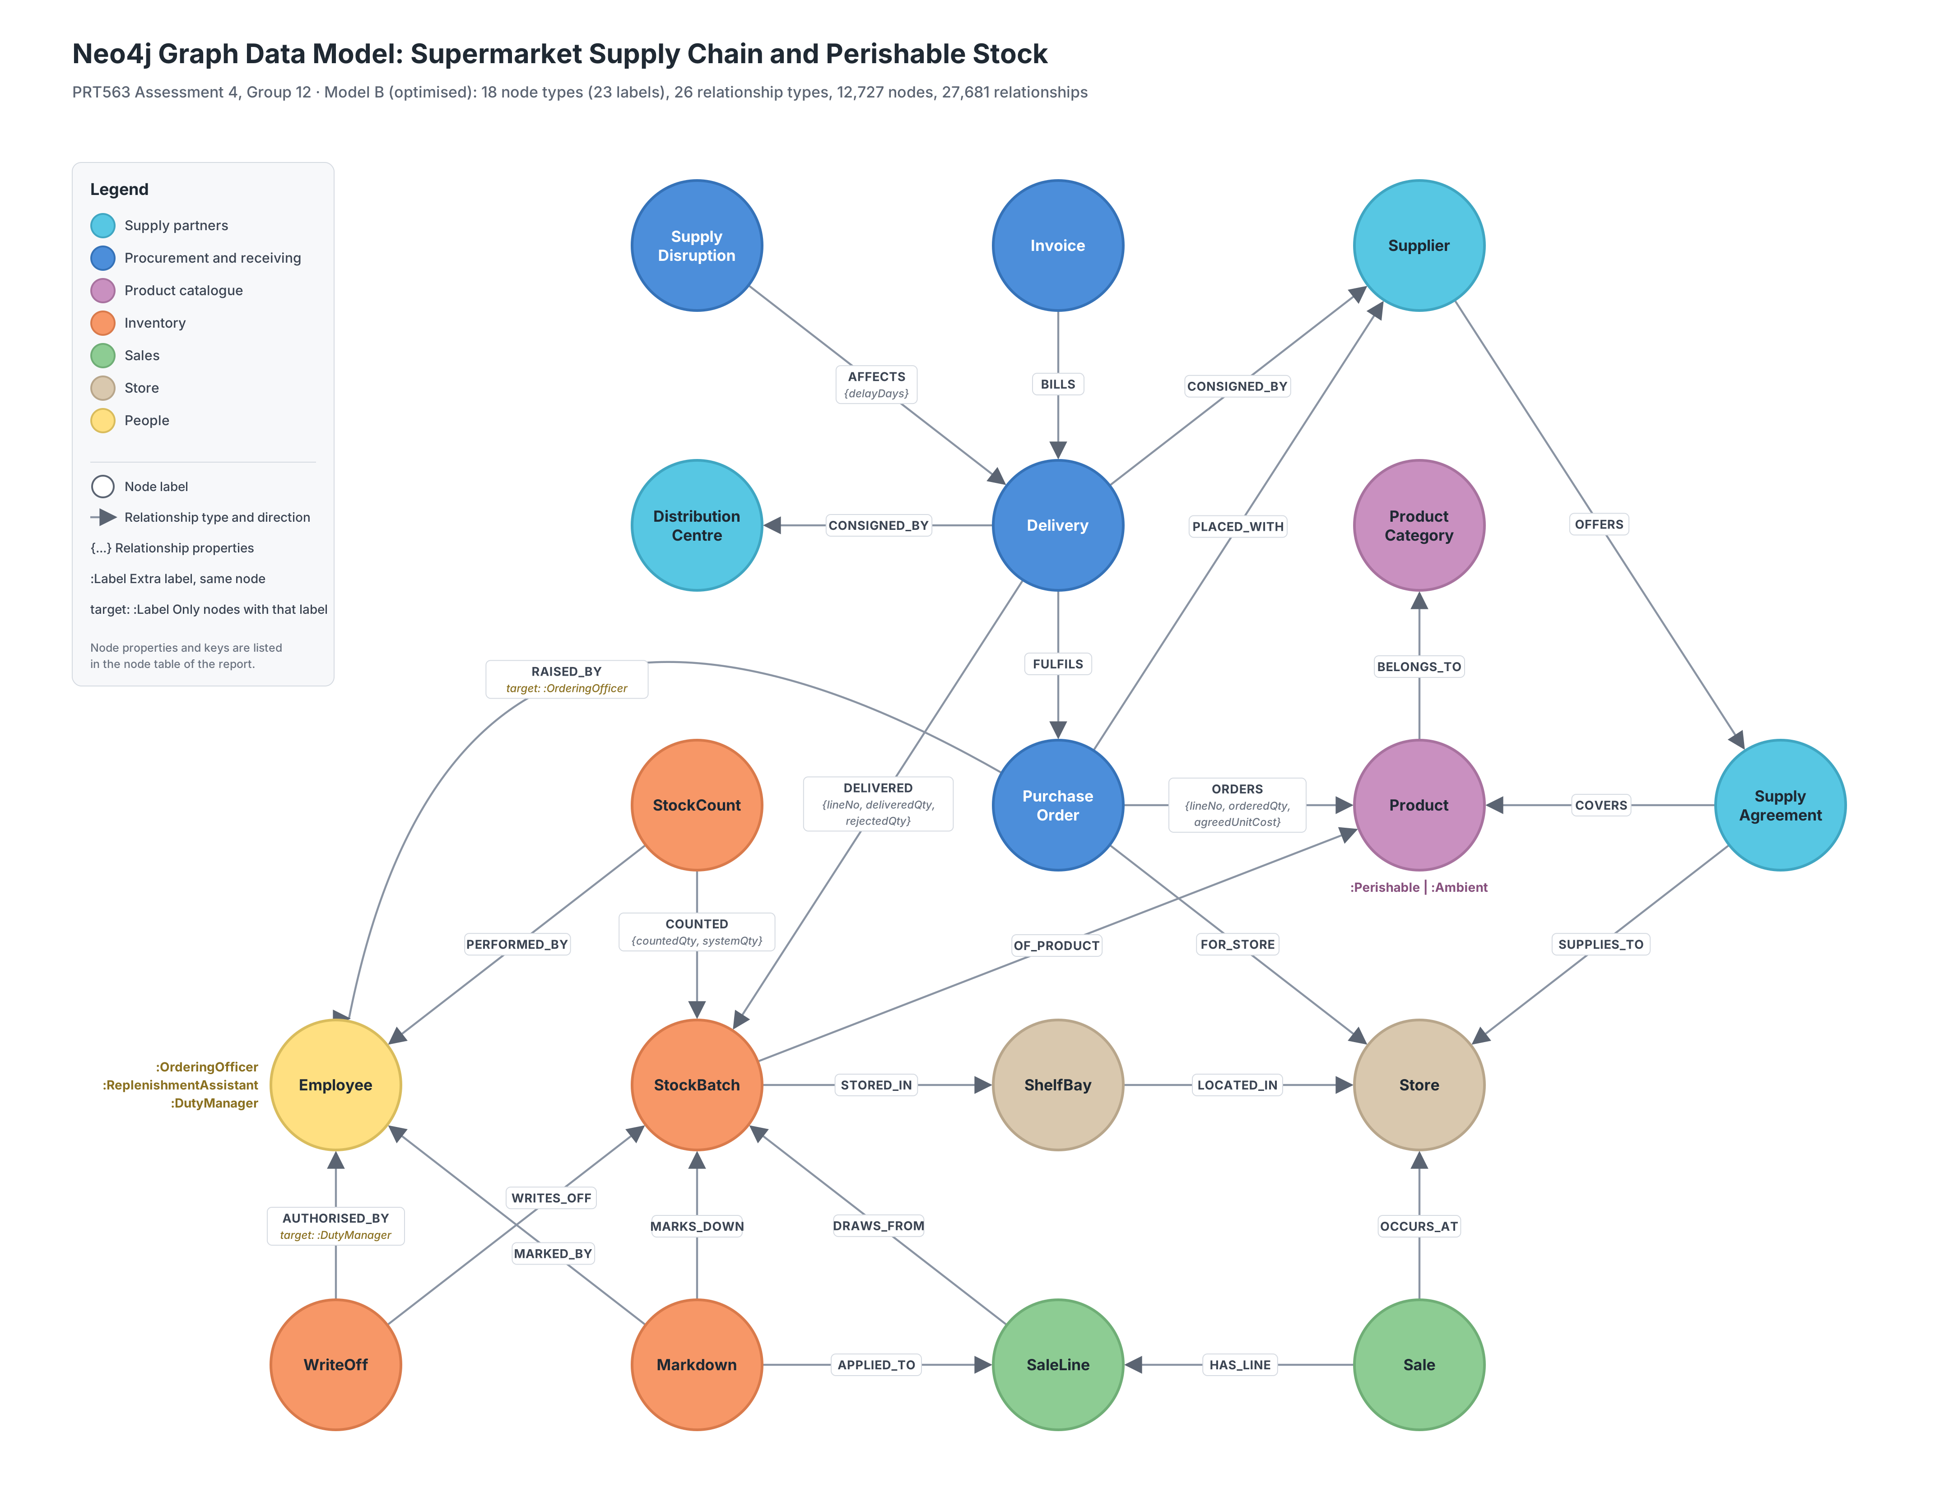
Figure 1. Model B graph data model with node counts, keys and relationship properties

3.3 Alternatives considered
The structures that remain as nodes are just as significant as those that are removed. SupplyAgreement links three entities (supplier, product and store), and SaleLine links a sale, a batch and optionally a markdown. These hyperedges (which are the graph representation of our Assessment 2 ternary relationship) are still nodes, as there can be only two nodes joined by a Neo4j relationship. Markdown remains a node, since SaleLine references it, and a relationship cannot be a target of another relationship, it is the graph representation of our EER aggregation. WriteOff could have been a relationship, since it connects only a batch and a duty manager, but it is defined as a business event with its own identity, date and reason, so it was retained as a node. The costs of optimisations are discussed in Section 9.

4 Task 2: Import and indexes
import.txt migrates the 29 CSV files in five parts: constraints, indexes, nodes, relationships, and clean up with verification. Every one of the 18 node keys is a uniqueness constraint. In addition to avoiding duplicates, the constraint also generates an index, which means that each MERGE and MATCH against a key is a direct look-up and not a label scan. The optimisations are made during load; an example of optimisation O5 is presented below where each PO_LINE row is transformed to an ORDERS relationship with properties.
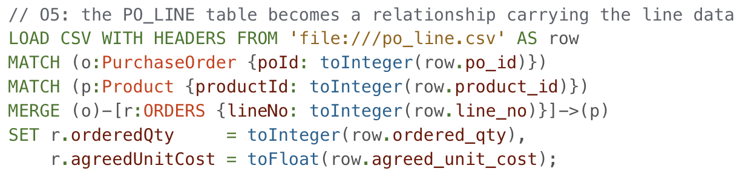
O2 had to be delivered a bit more carefully, as deliveries refer to a consignor that no longer exists as a node. Each supplier and DC temporarily stores its old consignorId with a temporary index, CONSIGNED_BY is built with the label expression (c:Supplier|DistributionCentre {consignorId: …}), and the temporary key and indexes are then removed. Types are explicitly converted, and nullIf converts empty CSV fields to real nulls instead of empty strings. Additional indexes were selected from the queries that the business actually executes (Table 2).
Table 2. Indexes created by import.txt and the queries they support
Index | Type | Supports
18 key constraints, e.g. batch_id | Range (uniqueness) | Every lookup by key; MERGE during import
batch_use_by, sale_datetime, delivery_date, markdown_applied | Range | Date filters: expiry windows, sales periods, the Task 5 hold out split
product_name_text | Text | CONTAINS searches on product names
delivered_rejected | Relationship property range | Quality checks on rejected stock
catalogue_search | Full text (Product, Supplier) | Free text recall search in Q3

Verification is built into the script (Figure 2). Check 3 confirms exactly 12,727 nodes and 27,681 relationships – the numbers expected from the CSV files based on expected_counts.py. Check 4 verifies that integrity constraints of the relational schema were kept: Each product is associated with exactly one subclass label, each delivery with exactly one consignor, each batch with exactly one delivery. Check 4b demonstrates three rules of the audits in the graph: that all the batches reconcile (in minus out minus written off = on hand), that no sale is outside the shelf life of its batch, and that no sale is made on another store's stock. Figure 3 reflects the same shape of the imported schema with the design.
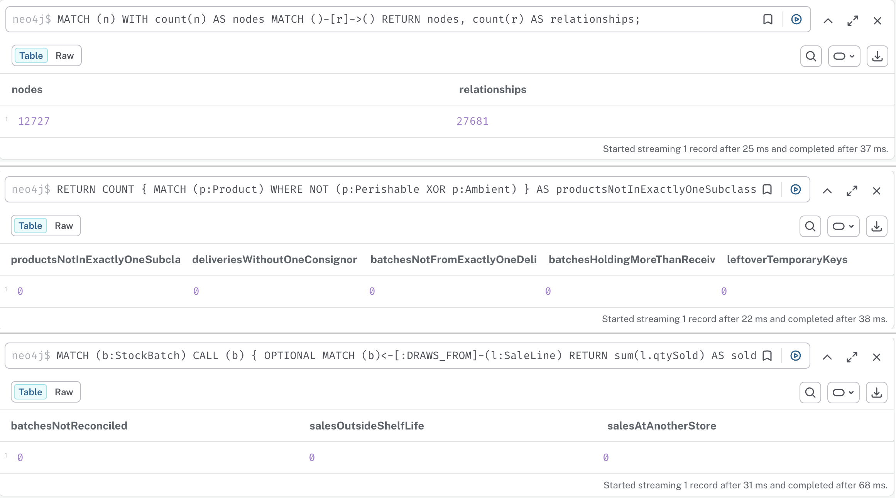
Figure 2. Import verification: totals (Check 3), relational integrity (Check 4) and stock and sales rules (Check 4b)
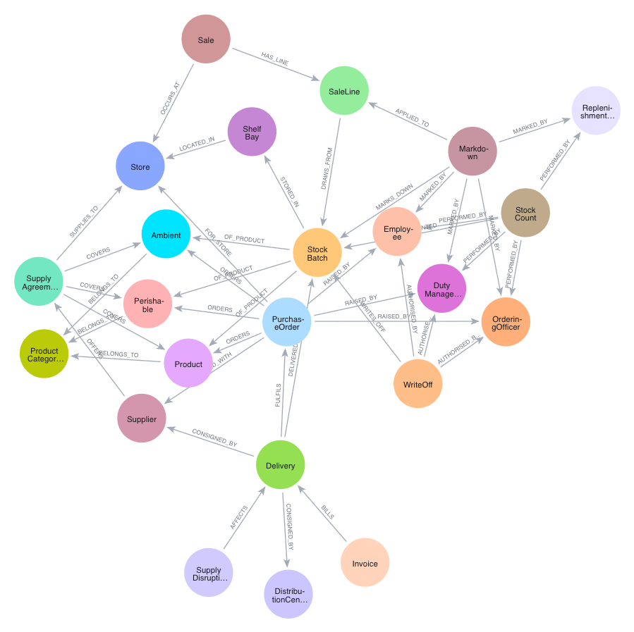
Figure 3. Schema of the imported graph from db.schema.visualization()

5 Alternative strategy experiment: Model A versus Model B
Typically, optimisations are done on the basis of argument; here they are measured. Model A was built in a second database (importA.txt) from the same CSV files, and seven business questions were written for both models (benchmark.txt). Each version was executed twice with PROFILE and the second (warm) version had to return the same answer as the first to demonstrate that no information had been lost in Model B. Database hits were used as the primary metric as they reflect the amount of work the engine is doing and unlike milliseconds do not fluctuate within the graph on this scale.
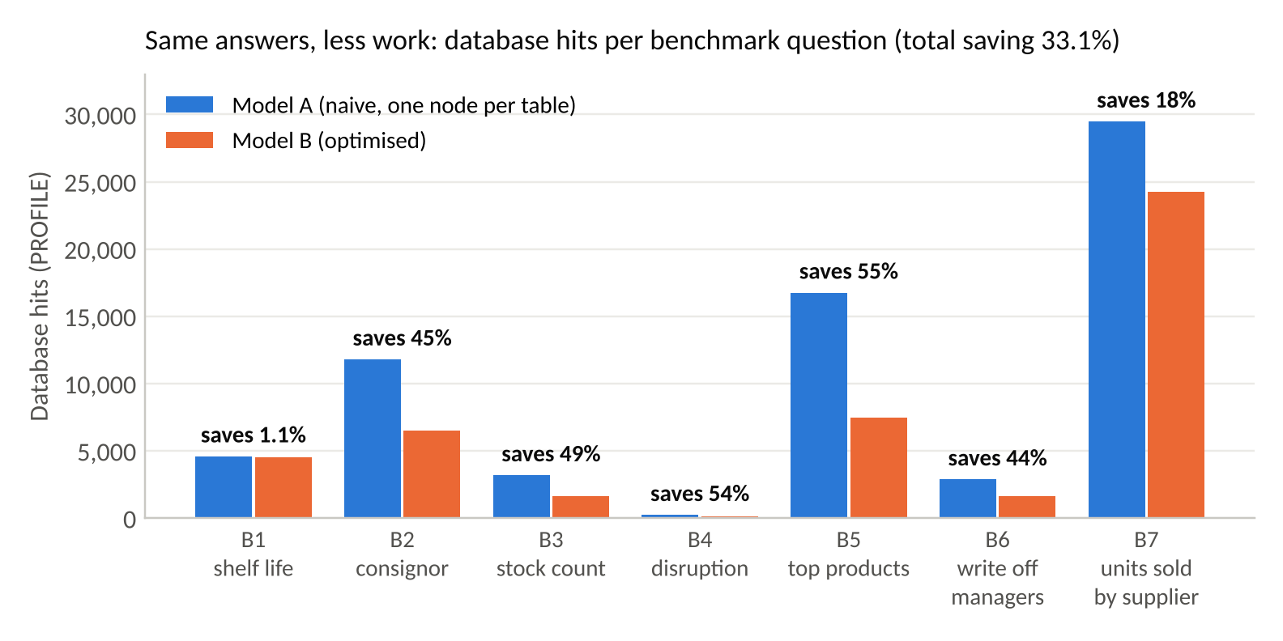
Figure 4. Database hits for seven benchmark questions on Model A and Model B
Model B halved the hops (20 to 10) and cut total database hits by 33.1% (68,994 to 46,146; Figure 4), while total elapsed time fell from 130 ms to 84 ms. The saving is not equal and the pattern is why. It is largest when the removed node was on a frequent path: the cost of replacing 1,858 PoLine nodes with ORDERS relationships was saved 55% on B5, and the cost of collapsing BatchCount and DisruptionImpact was about 50% saved on B3 and B4. It is smallest for B1 (1.1%), since the removed join only touches 20 product nodes, and moderate in B7 since three hops remain to be part of SaleLine as it is a hyperedge. The benefit of the optimisation is linear with the traffic flowing through the node that it is removing, providing a simple heuristic for future optimisations on which tables to collapse.

6 Task 3: Query use cases
The four use cases are progressively more sophisticated and they address questions that would be asked by managers of this business.

6.1 Q1 Cold chain breach at receiving (simple)
Food Standards Australia New Zealand (2025) requires chilled food to be received at 5 °C or colder. The ten worst deliveries of perishable products that were received more than 2 °C above the storage temperature of the product are listed in Q1. It matches 5 node types in one pattern, and uses the Perishable label (O1) instead of a join, and reads quantities from the DELIVERED relationship (O6).
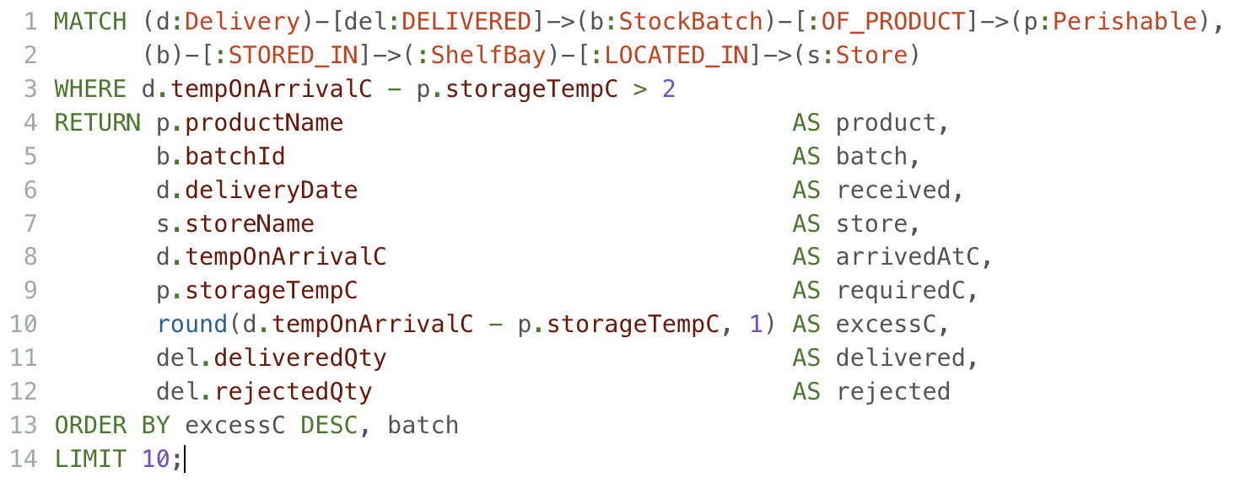
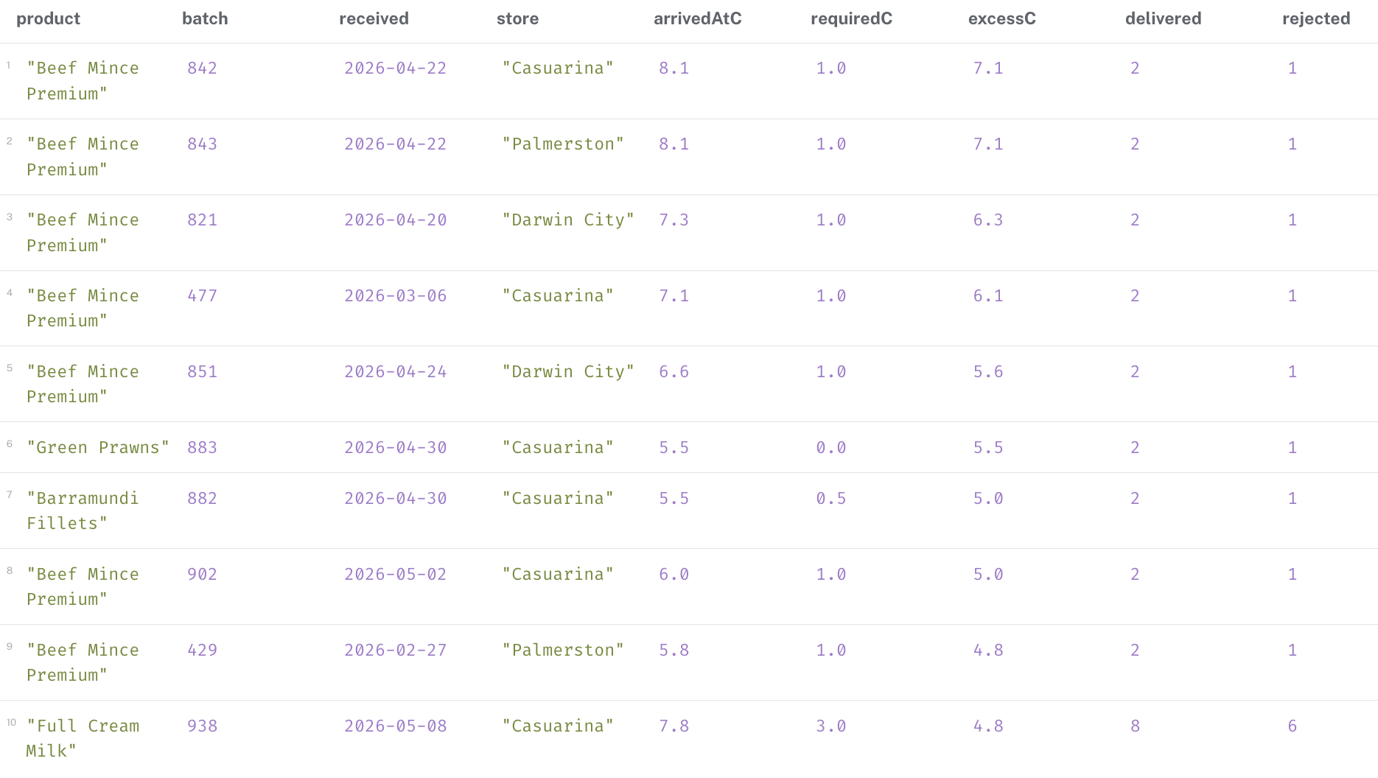
Figure 5. Q1 result: ten worst cold chain breaches
Sixty-three batches breach the rule (Figure 5). Beef Mince Premium leads the way and six of the 10 worst were delivered between 20-30 April – during and immediately after the Berrimah DC refrigeration failure, indicating the need for an audit of the DC's cold chain processes. All the stock shown was rejected by QA.

6.2 Q2 Supplier and DC scorecard (moderate)
Q2 rates every consignor on quality and timeliness for a quarterly review. The expression Supplier|DistributionCentre is used to replace the CONSIGNOR table and its two outer joins in the SQL version. The two CALL subqueries sum the totals per delivery before summing per consignor, thus avoiding row multiplication and double counting when one delivery contains several batches and a disruption. Timeliness is calculated based on duration against each purchase order's required date.inDays, and stock transfers that are not issued via POs drop out automatically, since count() ignores nulls (Neo4j, 2026a).
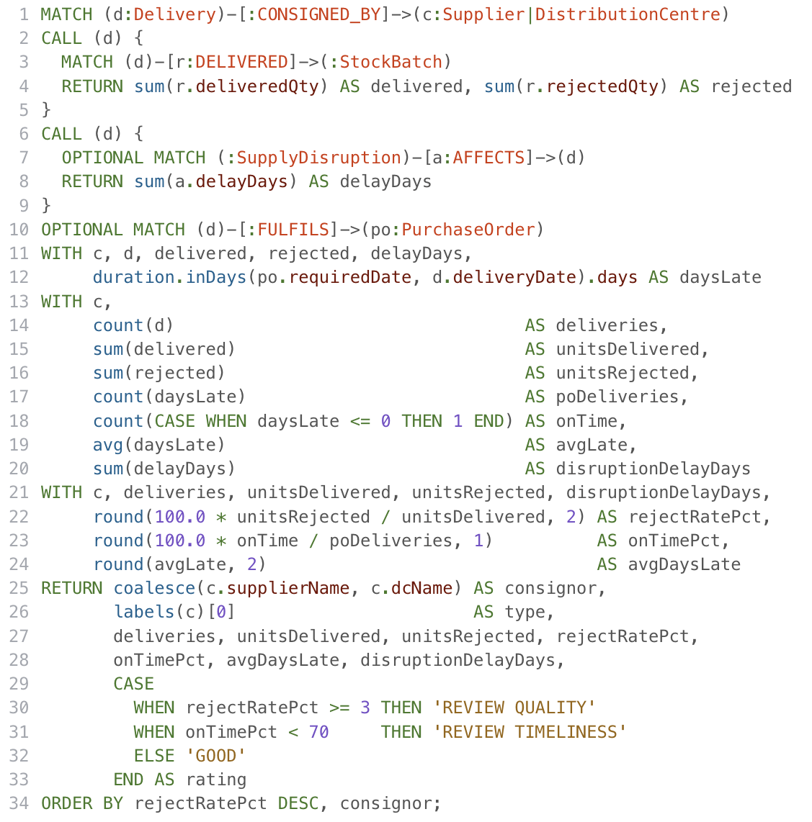
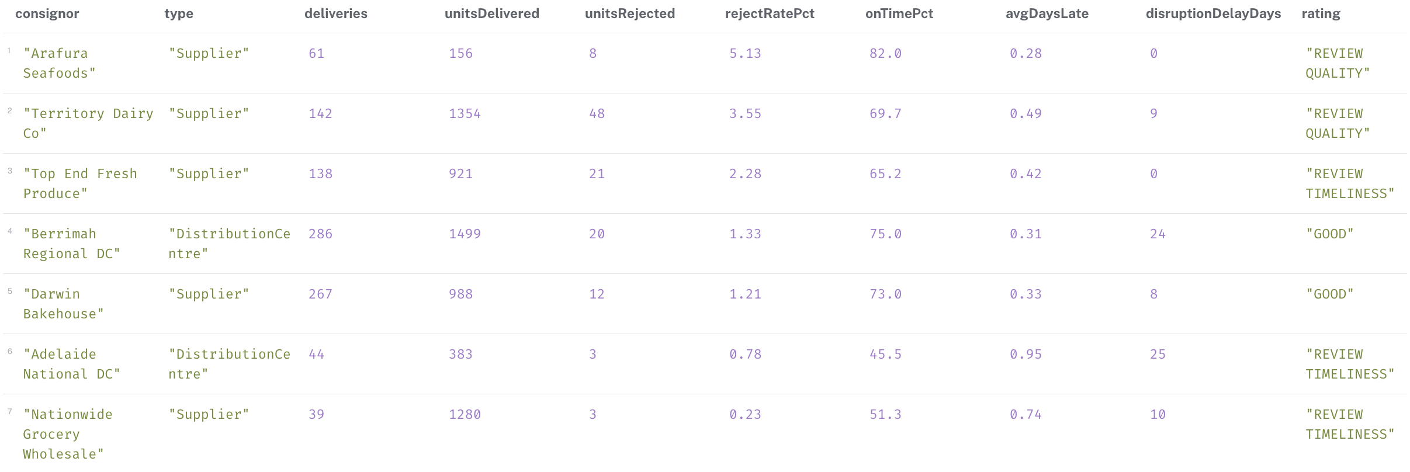
Figure 6. The delivery scorecard for all 7 consignors was produced in Q2.
Arafura Seafoods (5.13% of units rejected) and Territory Dairy Co (3.55%) need a quality review Arafura Seafoods (5.13% of units rejected) and Territory Dairy Co (3.55%) require a quality check (Figure 6). Top End Fresh Produce, Adelaide National DC and Nationwide Grocery Wholesale are noted for timeliness, with the interstate routes having the worst timeliness record (45.5% and 51.3%). The two DCs took the biggest disruption delay (25 and 24 days).

6.3 Q3 Product recall trace (complex)
Top End Fresh Produce had a recall on 20 July for Baby Spinach supplied from 13 to 19 July. The food safety team will require all affected batches, where the food was shelved, units sold (ACCOUNT payments) and buyers that can be contacted, and units pulled. Q3 begins with a full text index, meaning that staff can type in “spinach” and not an exact name, and then take a 7 hop journey, from supplier to store, using a chained date comparison. The pattern comprehensions capture each batch sales and recall write offs as a list of maps that are filtered using the WHERE; this is then passed to reduce() which totals it all up.
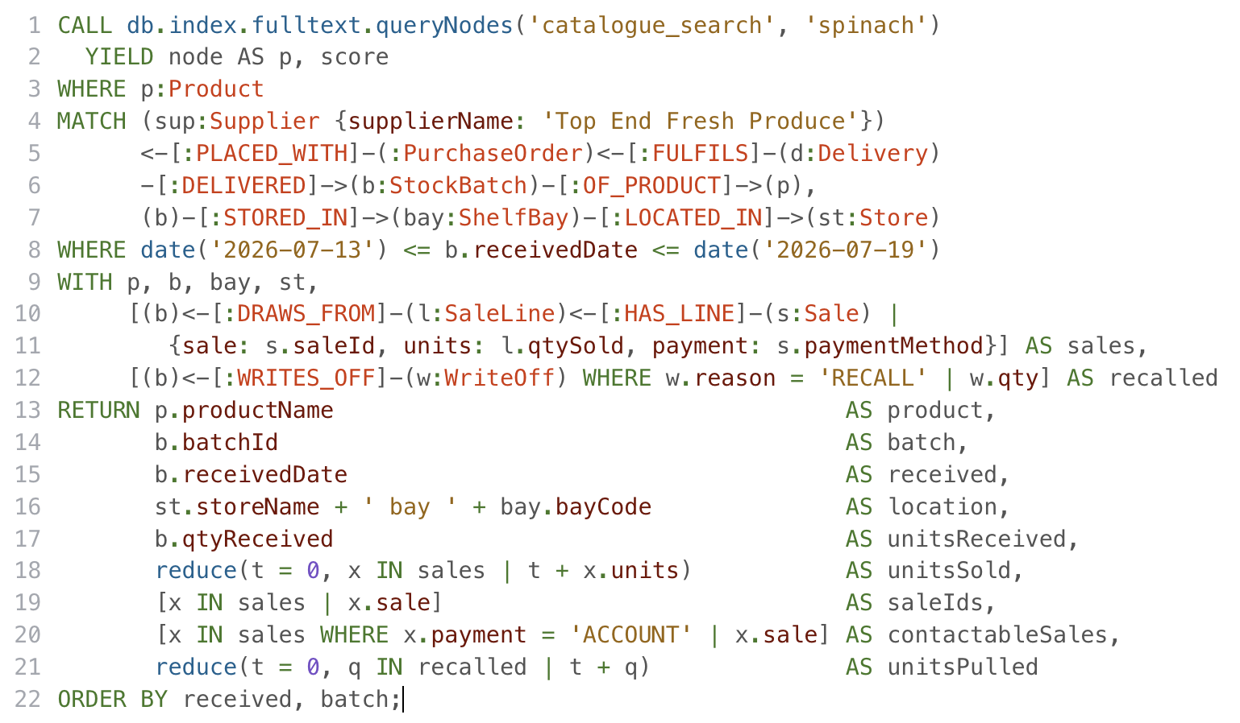
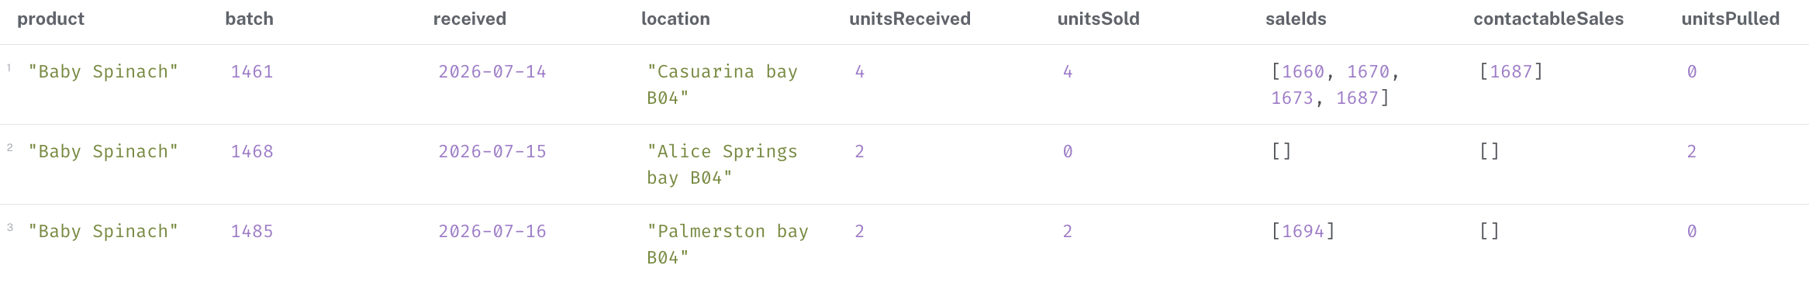
Figure 7. Q3 result: Baby Spinach recall trace
Three batches were impacted: 8 were received, 6 were sold, including one contactable buyer (sale 1687), and 2 were pulled from the Alice Springs shelf. This is the path it will follow in Cypher, seven joins and correlated subqueries in SQL.

6.4 Q4 Stock loss ledger by supplier (most complex)
Finance wants to know where the money leaks: Cost of stock purchased by each supplier, cost of expired stock and other write offs, revenue lost by markdowns, percentage of purchases lost and percentage of total losses, and the worst product. Q4 divides the set of write offs into a set of cost streams (conditional sums), then aggregates at two levels (supplier and product, then supplier), finds the worst product for each supplier with reduce(), and then uses collect() and UNWIND to append the company total beside every row – the Cypher version of the SQL window function.
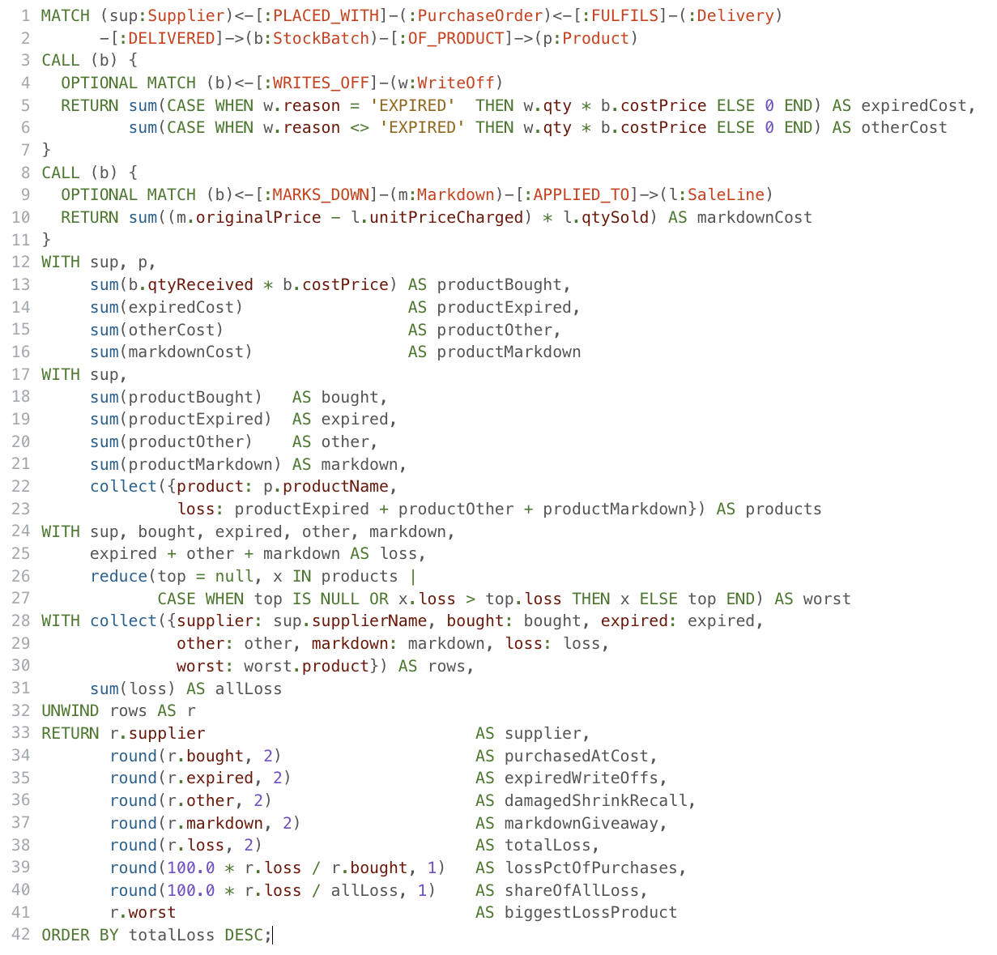
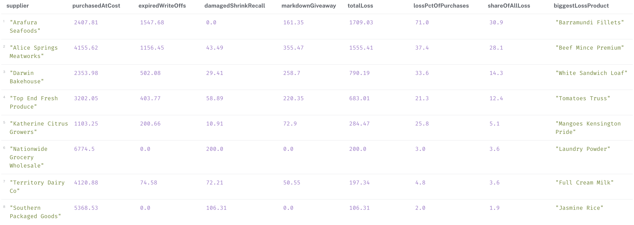
Figure 8. Q4 result: stock loss by supplier (AUD at cost; markdown at revenue forgone)
Arafura Seafoods and Alice Springs Meatworks account for 59% of all stock loss (Figure 8) and 22% of all purchases, with a loss value of 71% of purchases, primarily due to expiry. Ambient supplier losses are 2-3%. Section 8, then, focuses on seafood and beef, which are the two objectives of the bundling analysis.

7 Task 4: Centrality

7.1 Use case and projection

If one supplier or DC failed, which failure would hurt the stores most? The answer will determine where backup suppliers and contingency plans are required and needed first. A Cypher projection (gds.graph.project) creates a weighted supply network consisting of 34 nodes and 254 relationships: suppliers to products (SUPPLIES), suppliers to the DCs that supply them (SHIPS_VIA), suppliers and DCs to stores (DELIVERS_TO) and stores to the products they sell (SELLS), all of which are undirected and weighted by units. Centrality measure supply structure, not amount of paperwork, when projecting a purpose built network (Needham & Hodler, 2019).

7.2 Algorithms.
Eight configurations of five algorithms with varying notions of importance were tested in mutate mode, weighted and unweighted where applicable: Degree (number/volume of direct connections) (Freeman, 1978); PageRank (importance of important neighbours) (Page et al., 1999); Eigenvector; Closeness (net of nearness to all other nodes) (Bonacich, 1972); and Betweenness (how often a node appears on shortest paths) (Brandes, 2001). Betweenness was not weighted due to the fact that GDS considers a weight to be a distance, so high volume routes would be considered long. PageRank and Eigenvector required as many as 96 iterations, so maxIterations was increased from 20 to 200 and all runs converged.

7.3 Evaluation against ground truth
The four stores dominate the raw rankings: they are in between each supplier and each product with Casuarina being the top rank for every algorithm. In the case of supply risk decision the only concerned nodes are the 10 supply-side nodes, and algorithm is useful only in case it can rank the nodes according to real risk. An independent ground truth was thus calculated in Cypher based on the transactions: for each supplier or DC, the number of store, product pairs for which all observed supply routes go through it and the units. (Spearman, 1904) Spearman's rank correlation was used to compare each configuration with this truth which was also calculated in Cypher with list comprehensions and reduce() (Figure 9).
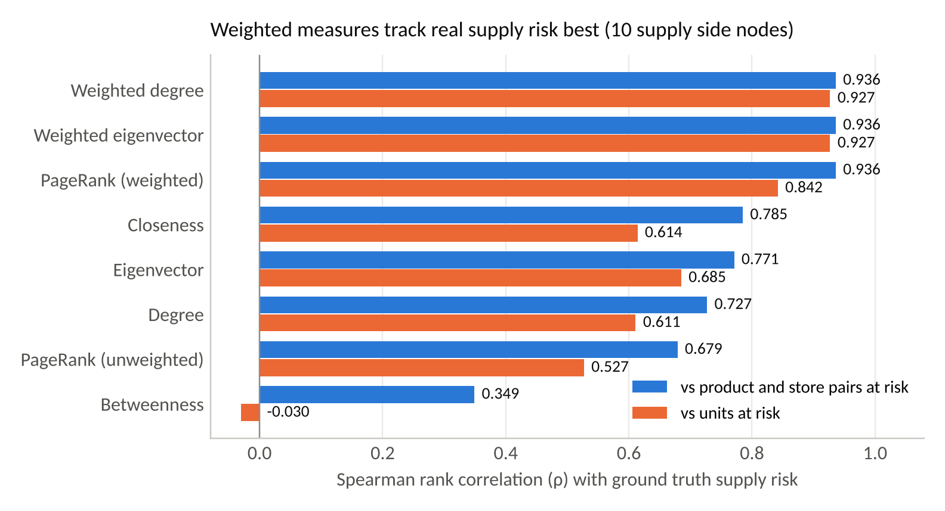
Figure 9. Spearman correlation of each centrality configuration with supply risk
There are three findings that stand out. First, weighting matters: the weighted measures attain a value of ρ = 0.936, compared to 0.68–0.77 for the unweighted measures; a supplier with daily delivery is more important than a supplier with monthly delivery. With ten nodes, ρ needs to be above 0.65 to be significant at the 5% level: between pairs, all measures except unweighted Eigenvector pass; between units, all measures but unweighted Eigenvector pass. Second, the ranking of weighted Eigenvector was the same as that of weighted Degree exactly. That's not random: GDS normalises relationship weights (Neo4j, 2026b) which, on an undirected graph, makes Eigenvector equivalent to a random walk whose stationary distribution will be proportional to weighted degree, and provides no additional computation here. Third, the Betweenness score is not suitable as a risk score (ρ = 0.349 for pairs; near zero for units) but it is used to answer a different question: among supply side nodes, Berrimah Regional DC is ranked first because suppliers that did not have their own transport route through the DCs.
Recommendation. The best risk score is “Weighted Degree”, which has the highest correlation on pairs and on units (0.927), is the most inexpensive to calculate and is easily explained. Weighted PageRank is a close alternative which becomes preferable if the network acquires tiers as it will propagate the importance along paths and Betweenness can be run as a chokepoint alarm. All weighted measures place Berrimah Regional DC as first, which is consistent with the ground truth (14 pairs and 1,184 units at risk), therefore, the first contingency investment should be a backup route for Berrimah Regional DC goods.

8 Task 5: Similarity

8.1 Use case and projection
Seafood, beef and bread were found to be the leading cause of stock loss in Q4. Understanding customer purchase trends behind these items can help with shelf placement, waste reduction bundles that are in close proximity of the markdown trigger and targeted promotions. Products are alike when they are in same baskets. To see if the methods predict future actions instead of describing past actions, the projection basketNet consists of 1546 nodes (20 products and 1526 baskets) and 9708 relationships, all of which are January to June sales. July and August were held out for testing, with 556 unseen baskets.

8.2 Methods
Four approaches were tried, all returning the top three partners per product. Node Similarity was done using three metrics: Jaccard, shared baskets / all baskets of either product; Overlap, shared baskets / smaller product baskets; and Cosine. The fourth approach is structurally distinct: FastRP (Chen et al., 2019) learns a 32-dimension embedding for each node, K Nearest Neighbours (Dong et al., 2011) finds products with similar embeddings. This is because that while KNN is approximate it scales to large catalogues, Node Similarity compares every pair, and the cost grows quadratically (Neo4j, 2026b). To make FastRP and KNN reproducible, a fixed seed with single thread concurrency was used.

8.3 Hold out evaluation
The recommendations on the test baskets were scored using the measures obtained from the association rule mining and recommender evaluation (Brinto et al., 1997; Shani & Gunawardana, 2011; Agrawal et al., 1993) which are lift, the ratio of a product and its partner appearing together in a basket to the number of times the product appears alone; confidence, the percentage of baskets with a product that also contain a recommendation for its partner; and precision@3, the percentage of recommendations in the top three partners of the product, in the test period. A best seller baseline, which displays the top three best sellers to all viewers, indicates whether a graph is servicing added value (figure 10).
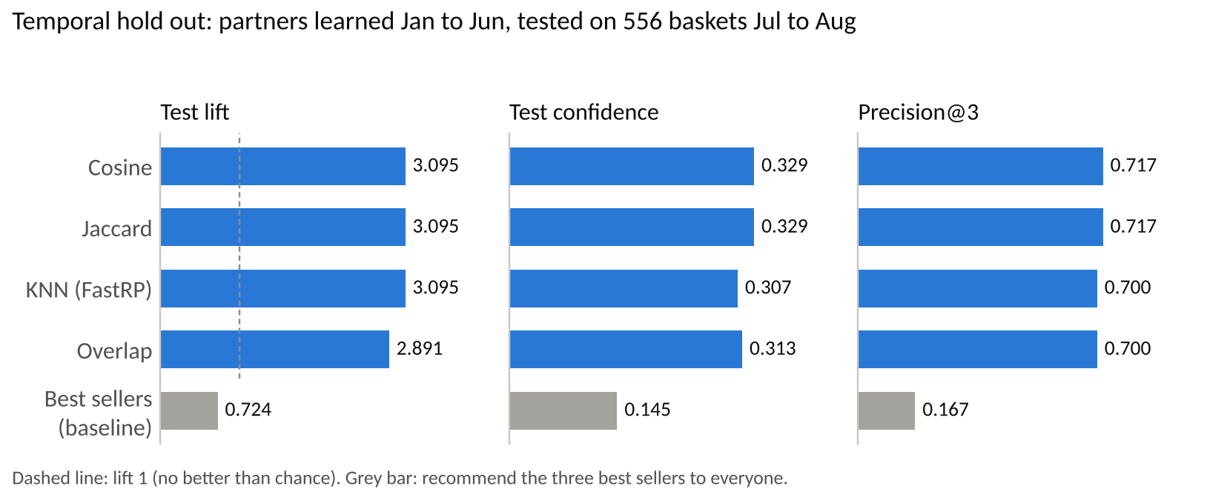
Figure 10. Compare evaluation of four methods of similarity to a best seller baseline
All four graph methods generalise with test lift near 3 and precision@3 0.70-0.72, compared to a baseline lift of 0.724: best sellers are not purchased together very frequently, and therefore popularity is not a good indicator of bundling. Jaccard and Cosine are equal on all the measures. The overlap is least as dividing by the smaller product's baskets tends to boost ratings for less frequently purchased products. KNN is as good as the best lift but less confident and some implausible partnerships like Full Cream Milk for Green Prawns as embeddings are more about overall neighbourhood shape than direct joint purchasing.
Table 3. Top three Jaccard partners of the high loss products (training period)
Product | Partners (Jaccard score)
Baby Spinach | Tomatoes Truss (0.254), Jasmine Rice (0.132), Olive Oil Extra Virgin (0.112)
Barramundi Fillets | Mangoes Kensington Pride (0.070), Baby Spinach (0.052), Olive Oil Extra Virgin (0.048)
Beef Mince Premium | Multigrain Rolls (0.255), Tomatoes Truss (0.161), Tasty Cheese Block (0.157)
Green Prawns | Baby Spinach (0.023), Tomatoes Truss (0.023), Jasmine Rice (0.022)
White Sandwich Loaf | Full Cream Milk (0.345), Bananas Cavendish (0.274), Greek Yoghurt (0.155)

Recommendation. Use Jaccard Node Similarity (ties for best accuracy, and scores can be interpreted by managers as a percentage of baskets, Table 3). Green Prawns are also a rare occurrence and therefore have a score close to zero. If the catalogue expands to thousands of products, then consider moving to FastRP with KNN. The partners have recommended three packs: a seafood pack (barramundi fillets with mangoes, baby spinach and olive oil); a barbecue pack (beef mince premium, multigrain rolls, tomatoes and cheese); and a breakfast pack (white sandwich loaf, milk, bananas and yoghurt).

9 Discussions and limitations
The migration highlighted the places where a graph was valuable. Simple lookups saw little benefit, but the recall trace saw shorter, clearer lookups and the benchmark indicated that the benefit depends on the traffic per removed node and not just the number of removed tables. The analytics also relied on the use of modelling – both centrality and similarity required purpose-built projections – not the raw transaction graph.
Several limitations apply. The transaction data is simulated. It follows all of the business rules, but some of the patterns like refrigeration failure and the recall are planted and recovering those patterns validates the approach but not real world behaviour, and the analysis should be repeated on production data. The graph is small: timings are noisy, and at production level, the import would have to be broken up into batches using a CALL IN TRANSACTIONS, or using the offline admin import tool. The centrality ground truth accounts for structural dependence and not for substitution; a store might purchase from another supplier during a crisis. The evaluations are also limited in size (10 supply side nodes, 556 test baskets) and should not be interpreted too literally.
There are costs associated with model B. Now line level data is hanging on relationships, which cannot be referenced by anything, and if a new need arises to link to a delivery line, then it is again a node. Role labels may become out of sync with their role properties, as it was done in the SQL schema, something property existence constraints in Neo4j Enterprise would reintroduce. Lastly, the hyperedges SupplyAgreement and SaleLine are as simplified as possible and, therefore, cannot be saved on paths like B7.

10 Conclusion
The relational database was migrated to a Neo4j graph that is smaller, faster and verified to be complete. First, auditing the data prevented 150 rule violations from becoming a problem for subsequent results. A comparison of the optimised model with a naive translation revealed a 33.1% decrease in database work and a general rule: Collapse the tables that carry the most traffic. The four use cases demonstrate that path queries, like a recall trace, are short and readable Cypher. Weighted centrality was determined to reliably indicate supply risk when evaluated against independent evidence and the basket similarity was found to predict future purchases three times more accurate than by chance, not by inspection of rankings. The business should consider adding a backup route to Berrimah Regional DC, look at Arafura Seafoods and Territory Dairy Co on quality and offer a seafood and barbeque bundle to minimise its largest losses.

References
Agrawal, R., Imieliński, T., & Swami, A. (1993). Mining association rules between sets of items in large databases. Proceedings of the 1993 ACM SIGMOD International Conference on Management of Data, 207–216. https://doi.org/10.1145/170035.170072
Angles, R., & Gutierrez, C. (2008). Survey of graph database models. ACM Computing Surveys, 40(1), 1–39. https://doi.org/10.1145/1322432.1322433
Bonacich, P. (1972). Factoring and weighting approaches to status scores and clique identification. The Journal of Mathematical Sociology, 2(1), 113–120. https://doi.org/10.1080/0022250X.1972.9989806
Brandes, U. (2001). A faster algorithm for betweenness centrality*. The Journal of Mathematical Sociology, 25(2), 163–177. https://doi.org/10.1080/0022250X.2001.9990249
Brin, S., Motwani, R., Ullman, J. D., & Tsur, S. (1997). Dynamic itemset counting and implication rules for market basket data. Proceedings of the 1997 ACM SIGMOD International Conference on Management of Data - SIGMOD ’97, 255–264. https://doi.org/10.1145/253260.253325
Chen, H., Sultan, S. F., Tian, Y., Chen, M., & Skiena, S. (2019). Fast and accurate network embeddings via very sparse random projection. Proceedings of the 28th ACM International Conference on Information and Knowledge Management, 399–408. https://doi.org/10.1145/3357384.3357879
Dong, W., Moses, C., & Li, K. (2011). Efficient k-nearest neighbor graph construction for generic similarity measures. Proceedings of the 20th International Conference on World Wide Web, 577–586. https://doi.org/10.1145/1963405.1963487
Elmasri, R., & Navathe, S. (2016). Fundamentals of database systems (Seventh edition). Pearson.
Receiving food | food standards australia new zealand. (n.d.). Retrieved 16 October 2026, from https://www.foodstandards.gov.au/business/food-safety/receiving-food
Freeman, L. C. (1978). Centrality in social networks conceptual clarification. Social Networks, 1(3), 215–239. https://doi.org/10.1016/0378-8733(78)90021-7
Jaccard, P. (1912). The distribution of the flora in the alpine zone. ¹. New Phytologist, 11(2), 37–50. https://doi.org/10.1111/j.1469-8137.1912.tb05611.x
Needham, M., & Hodler, A. E. (2019). Graph algorithms: Practical examples in Apache Spark and Neo4j (First edition). O’Reilly Media.
Introduction—Cypher manual. (n.d.). Neo4j Graph Data Platform. Retrieved 16 October 2026, from https://neo4j.com/docs/cypher-manual/25/introduction/
The neo4j graph data science library manual v2026. 09—Neo4j graph data science. (n.d.). Neo4j Graph Data Platform. Retrieved 16 October 2026, from https://neo4j.com/docs/graph-data-science/2026.09/
Robinson, I., Webber, J., & Eifrem, E. (2015). Graph databases (Second edition). O’Reilly.
Shani, G., & Gunawardana, A. (2011). Evaluating recommendation systems. In F. Ricci, L. Rokach, B. Shapira, & P. B. Kantor (Eds), Recommender Systems Handbook (pp. 257–297). Springer US. https://doi.org/10.1007/978-0-387-85820-3_8
Spearman, C. (1904). The proof and measurement of association between two things. The American Journal of Psychology, 15(1), 72. https://doi.org/10.2307/1412159

Individual contributions
Each member describes their own contribution below, in their own words.
Uttam Shrestha (S396560)
I audited the data of the Assessment 2 against 24 business rules, found 150 violations and wrote the simulation to re-create the tables of transactions without any violations, and documented it in such a way that the dataset could be reproduced exactly from a fixed seed. Then I applied the migration (Task 2): import.txt, uniqueness constrains, range, text, relationship and full text indexes, removed the CONSIGNOR table (temporary key strategy) and did the verification checks that the graph is the same as source data. I also assisted Yogesh in testing each optimisation's precondition against the regenerated data and assisted Abhisek in loading the Model A database for the benchmark test. Compiled and submitted the final report and meeting notes, coordinated the team channel, wrote the Introduction and Methodology and Import sections and created the reference list.
Sarin Uprety (S394012)
Centrality analysis (Task 4) was led by me. I constructed a weighted supply network projection of 34 nodes and 254 relationships, and executed eight different configurations of five GDS centrality algorithms in mutate mode, and compared results against an independent ground truth of supply risk using Spearman correlation calculated in Cypher. I worked with Yogesh on using the same evidence based evaluation approach with similarity methods. The Centrality section was written by me, as was the comparison of weighted and un-weighted measure and the suggestion for introduction of a back-up route to Berrimah Regional DC.
Yogesh Basnet (S394043)
I designed the graph data model (Task 1): I translated the Assessment 2 schema into the baseline Model A, identified the seven optimisations that produced Model B, checked each precondition against the data with Uttam and produced the model diagram and specification. I also conducted the similarity analysis (Task 5) using Jaccard, Overlap and Cosine Node Similarity with FastRP embeddings and K Nearest Neighbours and evaluated them against the best seller baseline using the evaluation approach developed with Sarin, with unseen baskets from July and August. I assisted Abhisek in testing the four queries and suggested the seafood, barbeque and breakfast packages. Graph Model, Similarity and Discussion sections are my own work, and I formatted the report, checked all of the numbers reported to the Neo4j results before turning it in.
Abhisek Tamang (S396739)
I created the four query use cases (Task 3) from the cold chain breach check to the stock loss ledger and verified each of these with independent calculations from the CSV files. I also carried out the experiment Model A versus Model B by profiling seven benchmark questions in two databases to see the saving in number of database hits, with the help of Uttam loading the Model A. I collaborated with Yogesh in testing the queries and verifying the loss figures, which focused the similarity analysis. I wrote the Executive Summary, Experiment, Query and Conclusion sections and produced the three report charts. I also created the project log and the GitHub repository where the team's decisions and progress are documented and the final report and charts were posted on it.

